GitHub commands:

1] git init – c:/<folder Location U want> **git init**

2] git status– to check the status of each file - Staging Area

3] git add –to add single file to GitHub e.g., **git add***<filename>*

4] git add . – to add all files in one single command

5] git commit m “”– initial commit **git commit -m “initial message”**

6] git log – to know date, time message of Ur commits

7] git diff – to know changes in file **git diff one.txt**

8] git checkout – to rollback file to its previous state

**git checkout one.txt**

Adding our Local Repository to Remote –

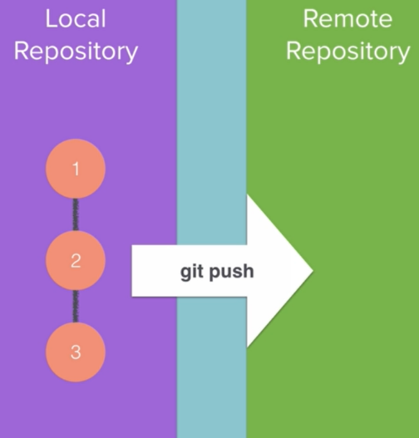

FIRSTLY, Do this–

**1.firstly create an account on GitHub**

[**https://github.com/**](https://github.com/)

**2.Create a Repository**

**3.git remote add origin** [**https://link_of_ur_repo**](https://link_of_ur_repo)

**4.git push -u origin master**

9]git branch – for temporary changes to our project for testing purpose git branch Is used

**git branch *branch-name***

9]to check in which branch your : Simply, git branch

To Switch branches: git checkout *branch-name*

To Merge branches: go to main branch by “git checkout” then

git merge *branch-name*

to Quit merge message = :q!

then – git push origin master -u